Movies Data Analytics

-- Copy movies dataset to hdfs directory
hdfs dfs -copyFromLocal /home/edureka/Desktop/project/movies.txt /pig
-- Starting Pig
Pig
-- Loading Movies Dataset
MoviesData = LOAD '/pig/movies.txt' using PigStorage(',') AS (custid:int,movie:chararray,year:int,rating:double,duration:int);

-- To find the number of movies released between 1950 and 1960.
F1 = FILTER MoviesData by ( year >= 1950 ) and ( year <= 1960 );
A = FOREACH ( GROUP F1 ALL ) GENERATE COUNT ( F1 ) ;
--dump A;
store A into '/pig/NumOfMoviesBW_1950_1960.txt' using PigStorage();

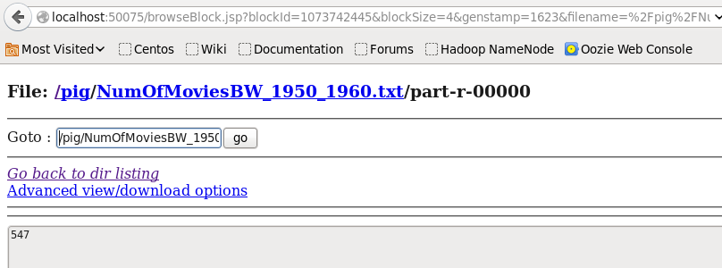

-- Find the number of movies having rating more than 4.
F2 = FILTER MoviesData by ( rating > 4 ) ;
B = FOREACH ( GROUP F2 ALL ) GENERATE COUNT ( F2 ) ;
--dump B;
store B into '/pig/NumOfMoviesRatingGreaterThan4' using PigStorage();

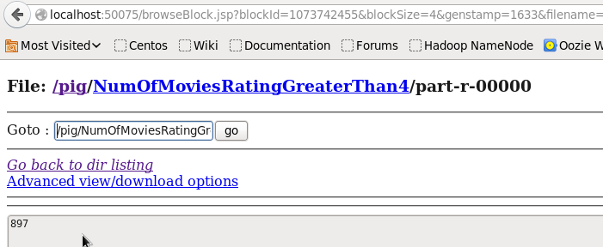

-- Find the movies whose rating is between 3 and 4.
F3 = FILTER MoviesData by ( rating >= 3 AND rating <= 4);
C = FOREACH ( GROUP F3 ALL ) GENERATE COUNT ( F3 ) ;
--dump F3;
store C into '/pig/NumOfMoviesRating_3_4' using PigStorage();

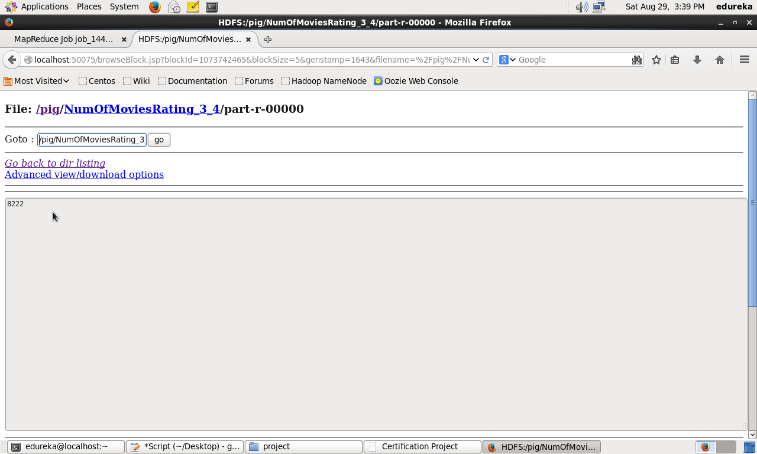

-- Find the number of movies with duration more than 2 hours (7200 second).
F4 = FILTER MoviesData by ( duration > 7200 );
D = FOREACH ( GROUP F4 ALL ) GENERATE COUNT (F4);
--dump D;
store D into '/pig/NumOfMoviesDurationMore_7200' using PigStorage();

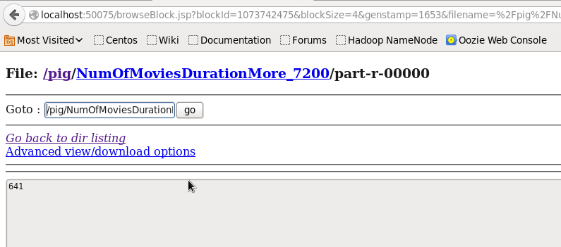

--Find the list of years and number of movies released each year
groupByYear = GROUP MoviesData BY year;
countByYear = FOREACH groupByYear GENERATE group AS Year, COUNT ( MoviesData ) as number;
--dump countByYear;
store countByYear into '/pig/YearsAndMovies' using PigStorage();

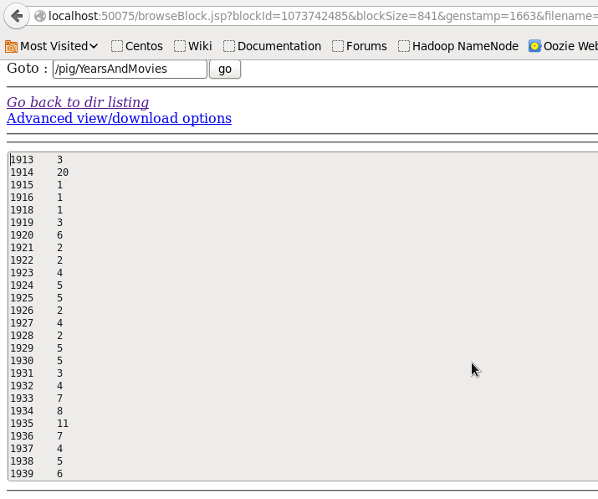
Full Solution File
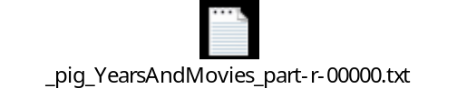
--Find the total number of movies in the dataset.
F = FOREACH ( GROUP MoviesData ALL ) GENERATE COUNT ( MoviesData );
--dump F;
store F into '/pig/TotalNumOfMovies' using PigStorage();

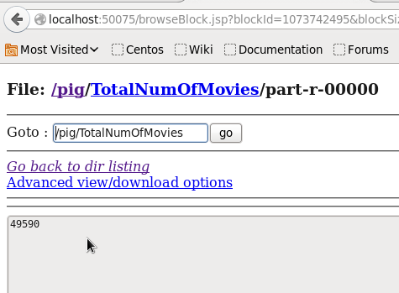

***The End***

